Energy Leadership Index® Assessment
Case Study Template

What is a case study?
A case study is a detailed story of a specific client you worked with and how your business helped them—including their initial challenge or goal (i.e., their ‘before’), the work you did together, and the transformation you helped facilitate.
Case studies are a great way to lend credibility to your business and showcase the effectiveness of your coaching services by harnessing the power of storytelling and using a ‘show don’t tell’ approach.

Why write a case study?
Creating a case study using this template is a true Level 5 opportunity. ✨
You’ll generate a high-impact marketing tool you can use to help grow your coaching business. Meanwhile, the win for iPEC is the opportunity to gather success stories from you, our coaches and share them with the world (with your permission, of course) to further underscore the ROI of coaching!

In addition to showcasing what coaching can do in a tangible way, a case study is also a great way to explain what the Energy Leadership Index® (ELI) is and illustrate its value to prospective clients. Using stories and examples, you can show how the ELI measurably enhances the effectiveness of your coaching services—and how you’ve used it with specific clients to reach their particular goals.
(Knowing that the ELI is a tool that’s exclusive to iPEC coaches, this can really help set your business apart!)
The case study template below will walk you through the process of crafting a compelling story of one specific client or organization/group you’ve worked with, with whom you used the ELI. You’ll use examples and specifics to show their before-and-after story, the results they were able to achieve with your support, and how the ELI played a role in their transformation.

Ways you might use case studies to grow your business
- Consider using your case studies as lead magnets on your website. This simply means offering your case study for download in exchange for a prospective client’s email address so you can follow up with them with more information about your services, nurture them via email, etc.
- You can also create multiple case studies to highlight the different types of clients you work with and the many ways you’ve helped them achieve different goals using the ELI. You could even compile them into a library on your website!
- Consider plucking out compelling quotes or segments from your case studies and sharing them on your social media channels with a link back to your website. (And don’t forget to tag @ipeccoaching so we can share it, too!)

Ready to get started? Use the template below to start telling your story–and be sure to check out the last page of this document for some additional writing tips to help your case study really sing!


[Case Study Title]
For the title, aim for ~70 characters or fewer and mention either Energy Leadership® or the ELI

Introduction
Aim for about a 100-word introduction that briefly introduces readers to:
- The Energy Leadership™ Index (ELI) assessment is the proprietary, research-backed attitudinal assessment tool, created by iPEC, that takes something abstract—the way you experience the world—and turns it into a tangible metric. The ELI is an assessment to awaken your potential and reshape your world.
- Your client’s name + some basic information about them.
  - You’ll have a chance to get more into the details later—this is more about introducing them as the ‘main character’ of this story.
  - Also, be sure you have their consent to feature them!
- The main opportunity this client saw when they decided to work with you



- A brief, contextual introduction to the ELI for readers who aren’t familiar with it. Include what it is and what made it a valuable tool to use with this client.
⭐Feel free to reference the ELI Marketing Toolkit for approved language you can pull from! Please also link back to this page on the iPEC website when you’re introducing and explaining the ELI.

[Client Name]’s Story
In this section, provide a more in-depth introduction to your client and the main goals and/or challenges they were facing when they decided to work with you.
“If possible, include at least one quote from your client in this section to infuse their own words into the story.”

How the Power of Coaching and the ELI Helped [Client Name] [main thing they gained or achieved from your work together]

Here you’ll focus on laying out the stakes: explain the main challenge or opportunity this client wanted support around, why they decided to hire you, and what they were hoping would change.
You can also share a little bit here about their ‘before’ picture—i.e., what life was like for them before working with you—to help set the stage for the transformation! If the ELI played a role in their decision to hire you, consider including that, too.

The [“Challenge” or “Opportunity”] [Client Name] was Facing



In this section, share some key insights or ‘aha’s’ from their ELI debrief and/or how those insights carried into your coaching engagement to help them achieve their desired outcome. Be as specific as you can here about the shifts that began taking place and how the ELI enabled those shifts to happen, while also being careful not to break client confidentiality or share details that are too personal. (When in doubt, check in with your client to get their buy-in and consent!)
The Results
To close the case study, speak to the role that the ELI played in your work with this client and in the transformation they experienced! Refer back to their initial challenge or goal and compare it to the results they achieved by the end of their work with you.

Include any relevant quotes, visuals, and/or quantifiable results that help emphasize their transformation and the impact of your work together.
Be sure to include a link to your services page, your contact page, or an email address so that they have a clear and easy next step to take.

Include any relevant quotes, visuals, and/or quantifiable results that help emphasize their transformation and the impact of your work together.
X%
Increase in ____
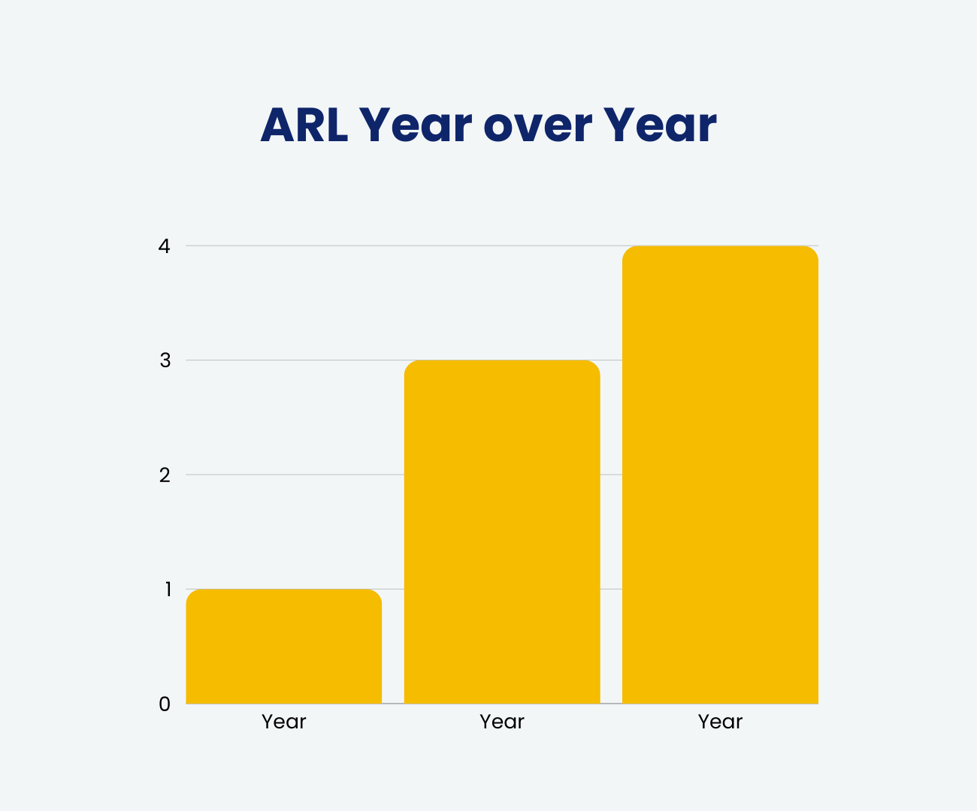
Use this section to highlight anything left unsaid about the power of coaching and/or the ELI (keep it succinct!)

Encourage the reader to get in touch with you if they’re interested in exploring how you might be able to help them, too.

Other Useful Writing Tips
When developing your case study article, consider the following Do’s and Don’ts. (We pulled many of these straight from our own brand guidelines!)

DO:
- Use bullet lists, numbered lists, and subheadings where appropriate, for easy readability.
- Say what you mean and don’t say anything else. A good practice is to write something as simply and as plainly as you can, and then come back to sprinkle in fun, lighthearted language and tie it to the needs of the reader.
- Pepper in sparkling and lively language. Emojis are encouraged too, for a humorous, relatable illustration, without overusing them. 😎
- Avoid formality for the sake of formality. In general, follow AP style and ensure copy is correct and clear, but strive for copy that reads like a comfortable and casual conversation.
- Write from the heart AND the head. Balance speaking to the readers’ emotions and their logic.
- Cite your sources if you choose to reference outside research or data.

DON’T:
- Sacrifice clarity for cleverness. The goal here is to make iPEC accessible for internal and external audiences alike.
- Overuse capitalized letters or punctuation to make a point. Excitement can be crafted through words.
- Use passive or lukewarm language. When using active language to bring movement and life (and energy!) to your writing, allow for nuance but hold firm to your message and values.

